

Exercise 1: Logging Error Messages and Warning Levels

Task: Write a Java application that demonstrates logging error messages and warning levels using SLF4J.

**Solution:**

1. **Add SLF4J & Logback** dependencies to the **pom.xml**.

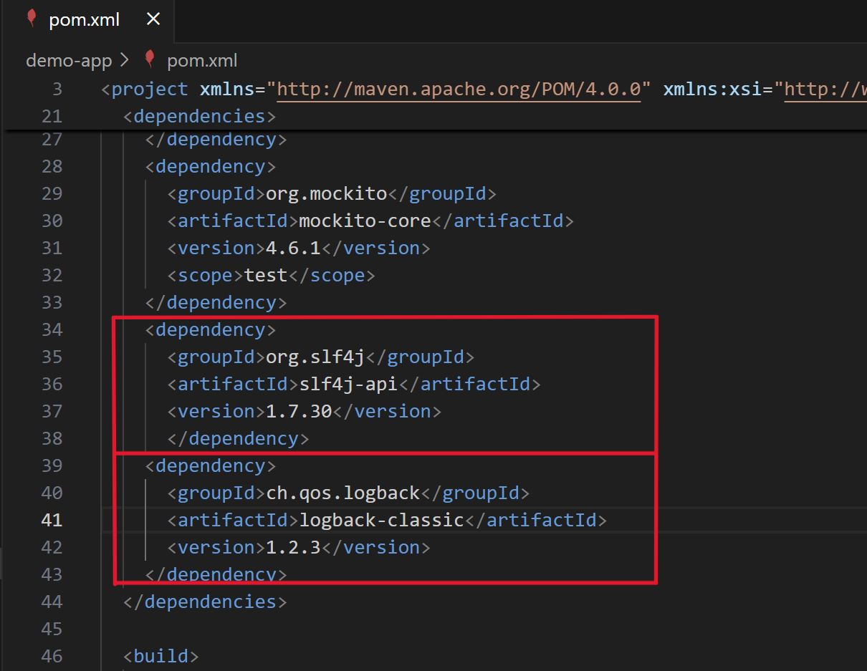

1. **Created** a simple **LoggingExample** Java **class** that logs error and warning messages. :
2. Run it and see log output in the console.

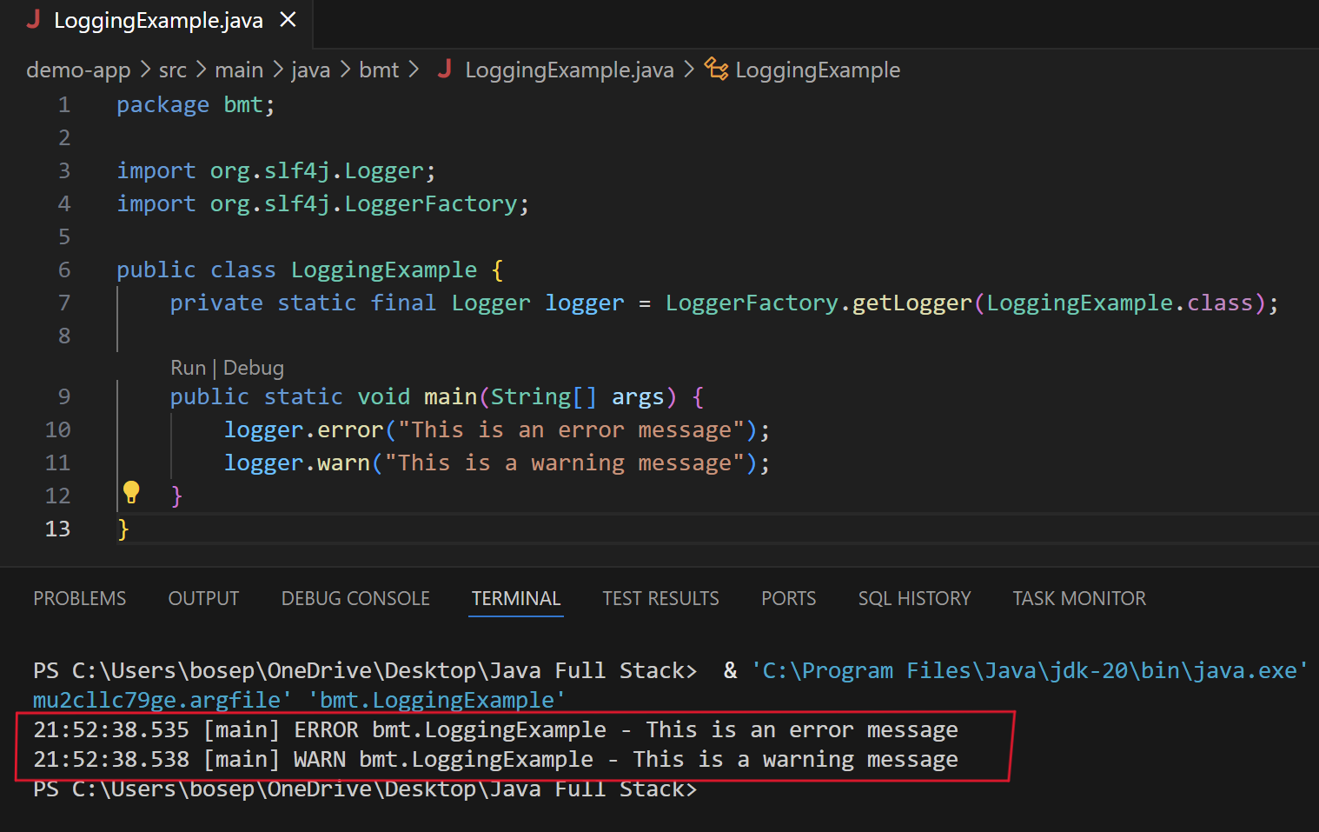

▪ Therefore , from the above steps we have :

a. Integrated **SLF4J** as our logging API.  
 b. Used **Logback** as the backend implementation.  
 c. Logged at error and warn levels.

******************************************************************************************